Unit____Genetics_____
Name______________ Period___
Monohybrid Crosses – Simple Dominance
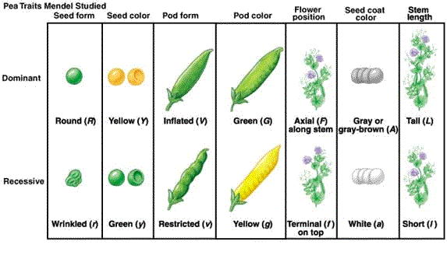
Part 1: Using the traits and alleles from this chart, indicate the possible genotype(s) for the following plants:
1. Homozygous wrinkled _________________________
2. Homozygous round _________________________
3. Round heterozygous _________________________
4. Yellow seed hybrid _________________________
5. Heterozygous green pods _________________________
6. Yellow pods _________________________
7. Short stems _________________________
8. Tall stems _________________________
9. Yellow seeds _________________________
10. Pure tall stem _________________________
11. Homozygous tall stem _________________________
12. Heterozygous tall stem _________________________
Part 2

A Punnett Square is a shortcut tool that shows how genes from 2 parents could possibly combine in the offspring.
Punnett Squares are used to predict the probability of producing certain types of offspring.

Example Problem: Cross a heterozygous tall pea plant with a heterozygous tall pea plant.
Solution: When solving a genetics problem, ALWAYS follow these 5 steps:

Step 1: Select the letter for the gene. Decide which allele is DOMINANT or recessive.
T = __________________ t = _____________________
Step 2: Determine the genotypes of the parents from the info in th problem: P₁ =____ P₂ = ____ Write it like this: Parental Cross = ____ X ____
Step 3: Make a Punnett Square.

- Parent gametes go outside.
- The possible offspring combination (F₁ gen.) goes inside.

Step 4: Genotypic Ratio:__________ : _________ : _________
Homoz. Dom. Heteroz. Homoz. Rec.

Step 5: Phenotypic Ratio: ___________ : ____________
Tall Short

Ratios can also be expressed as percentages: _____________, or fractions: ____________.

Now it is your turn…

Perform the following genetic crosses. These crosses are based on traits that Gregor Mendel saw in his pea plants.

1. Round seeds are dominant over wrinkled seeds. Cross: Pure round seeds x Pure wrinkled seeds.

Step 1:

Step 2: Step 3:

Step 4:

Step 5:
2. Green pods are dominant over yellow pods. Cross: Hybrid green pods x Hybrid green pods.

Step 1:

Step 2: Step 3:

Step 4:

Step 5:

3. Axial flowers are dominant over terminal flowers. Cross: Hybrid axial flowers x Pure axial flowers.

Step 1:

Step 2: Step 3:

Step 4:

Step 5:

4. Self-pollinate a short pea plant. What are the genotypes and phenotypes of the offspring?

Self-pollination means that a plant fertilizes itself. Pollen from the anther falls onto the stigma of the same flower. So, egg and sperm (pollen) are coming from the same plant.

Step 1:

Step 2: Step 3:

Step 4:

Step 5:

Part 3: In humans, brown eyes (B) are dominant over blue eyes (b).
Write the genotypes of the following individuals:
1. Heterozygous for eye color _________________________
2. Homozygous brown eyes _________________________
3. Heterozygous brown eyes _________________________
4. Blue eyed woman _________________________

In humans, the ability to roll the tongue is dominant (R). Non-rolling is a recessive allele (r).
Write the genotypes of the following individuals:
5. Non-roller _________________________
6. Roller _________________________
7. Homozygous roller_________________________
8. Heterozygous roller _________________________
9. Homozygous non-roller_________________________

Part 4: Perform the following monohybrid crosses using Punnett squares.
1. Cross a heterozygous brown-eyed woman with a heterozygous brown-eyed man. What are the genotypic and phenotypic ratios of the possible offspring (F1 generation)? (Remember to follow the five steps!)

2. Cross a hybrid yellow seeded pea plant with a pure green seeded pea plant. What are the genotypic and phenotypic ratios of the F1 generation?

